Tab 1

***Name:Patel Ansh Sanjaybhai***

***Enrollment No:2302031800121***

***Class:4CSE_E***

***Branch:BTech CSE***

**1.Sign In Page:**

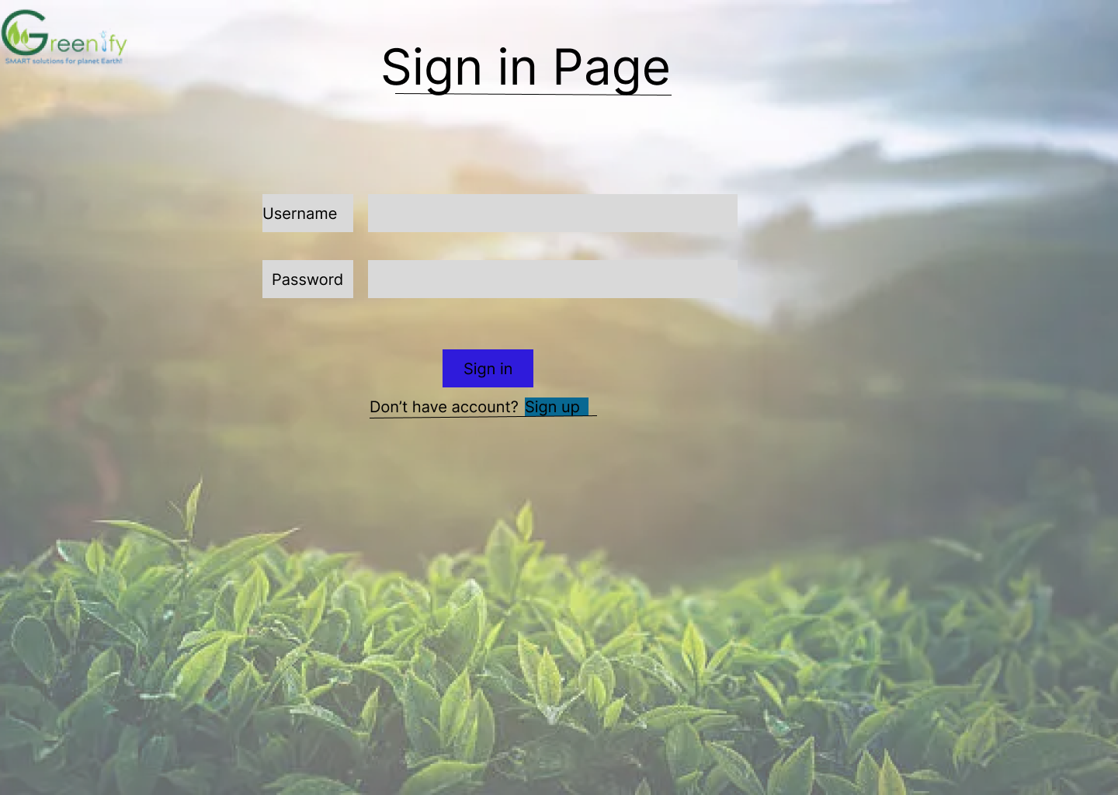

**2.Sign Up Page:**

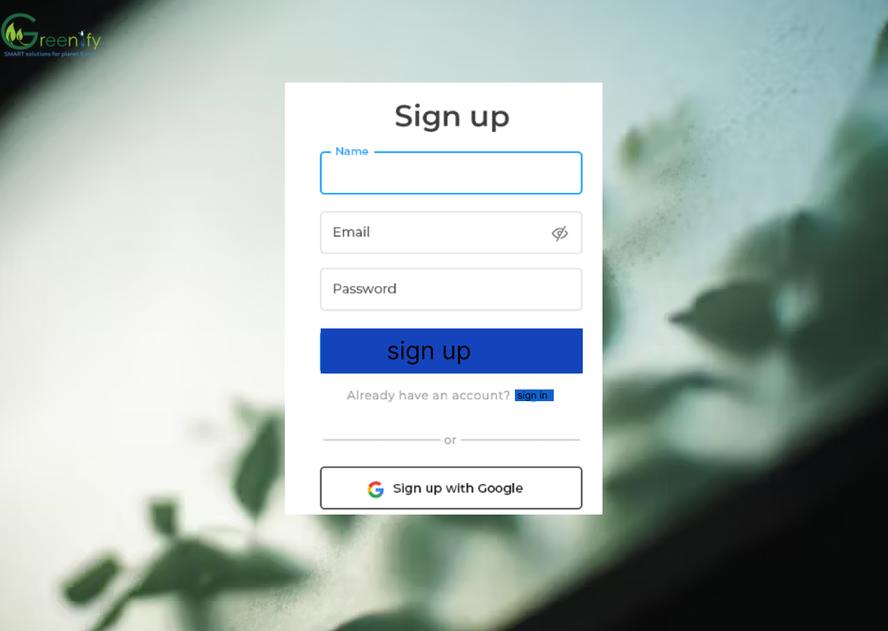

**3.Home Page:**

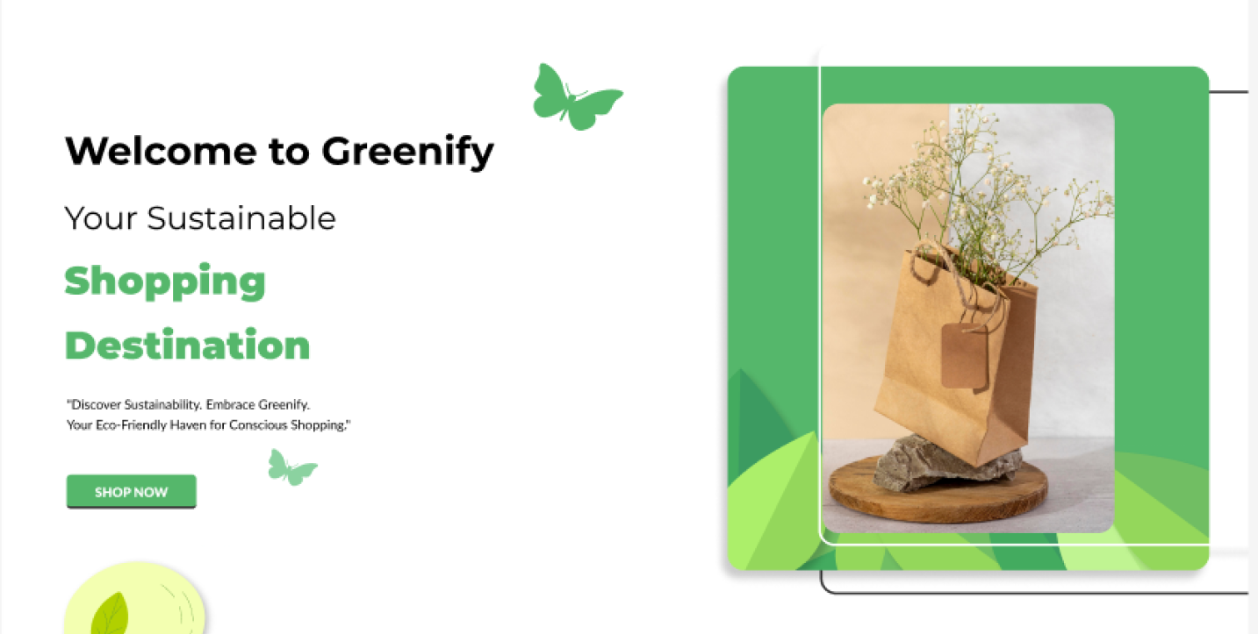

**4.Why Choose Greenify:**

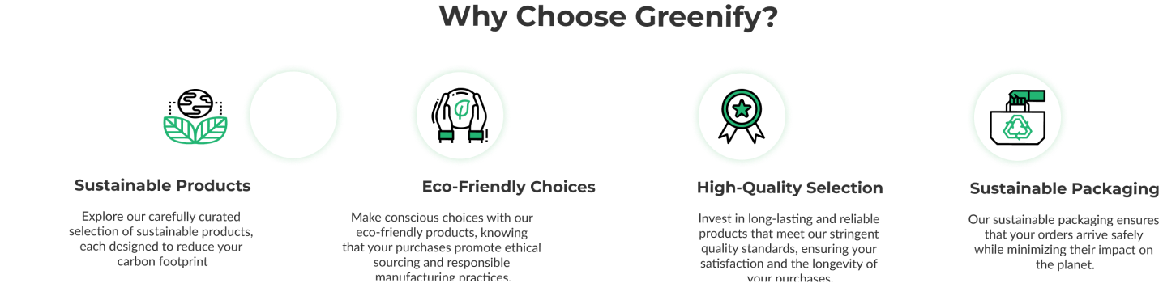

**5.Our Best-Selling Sustainable Product:**

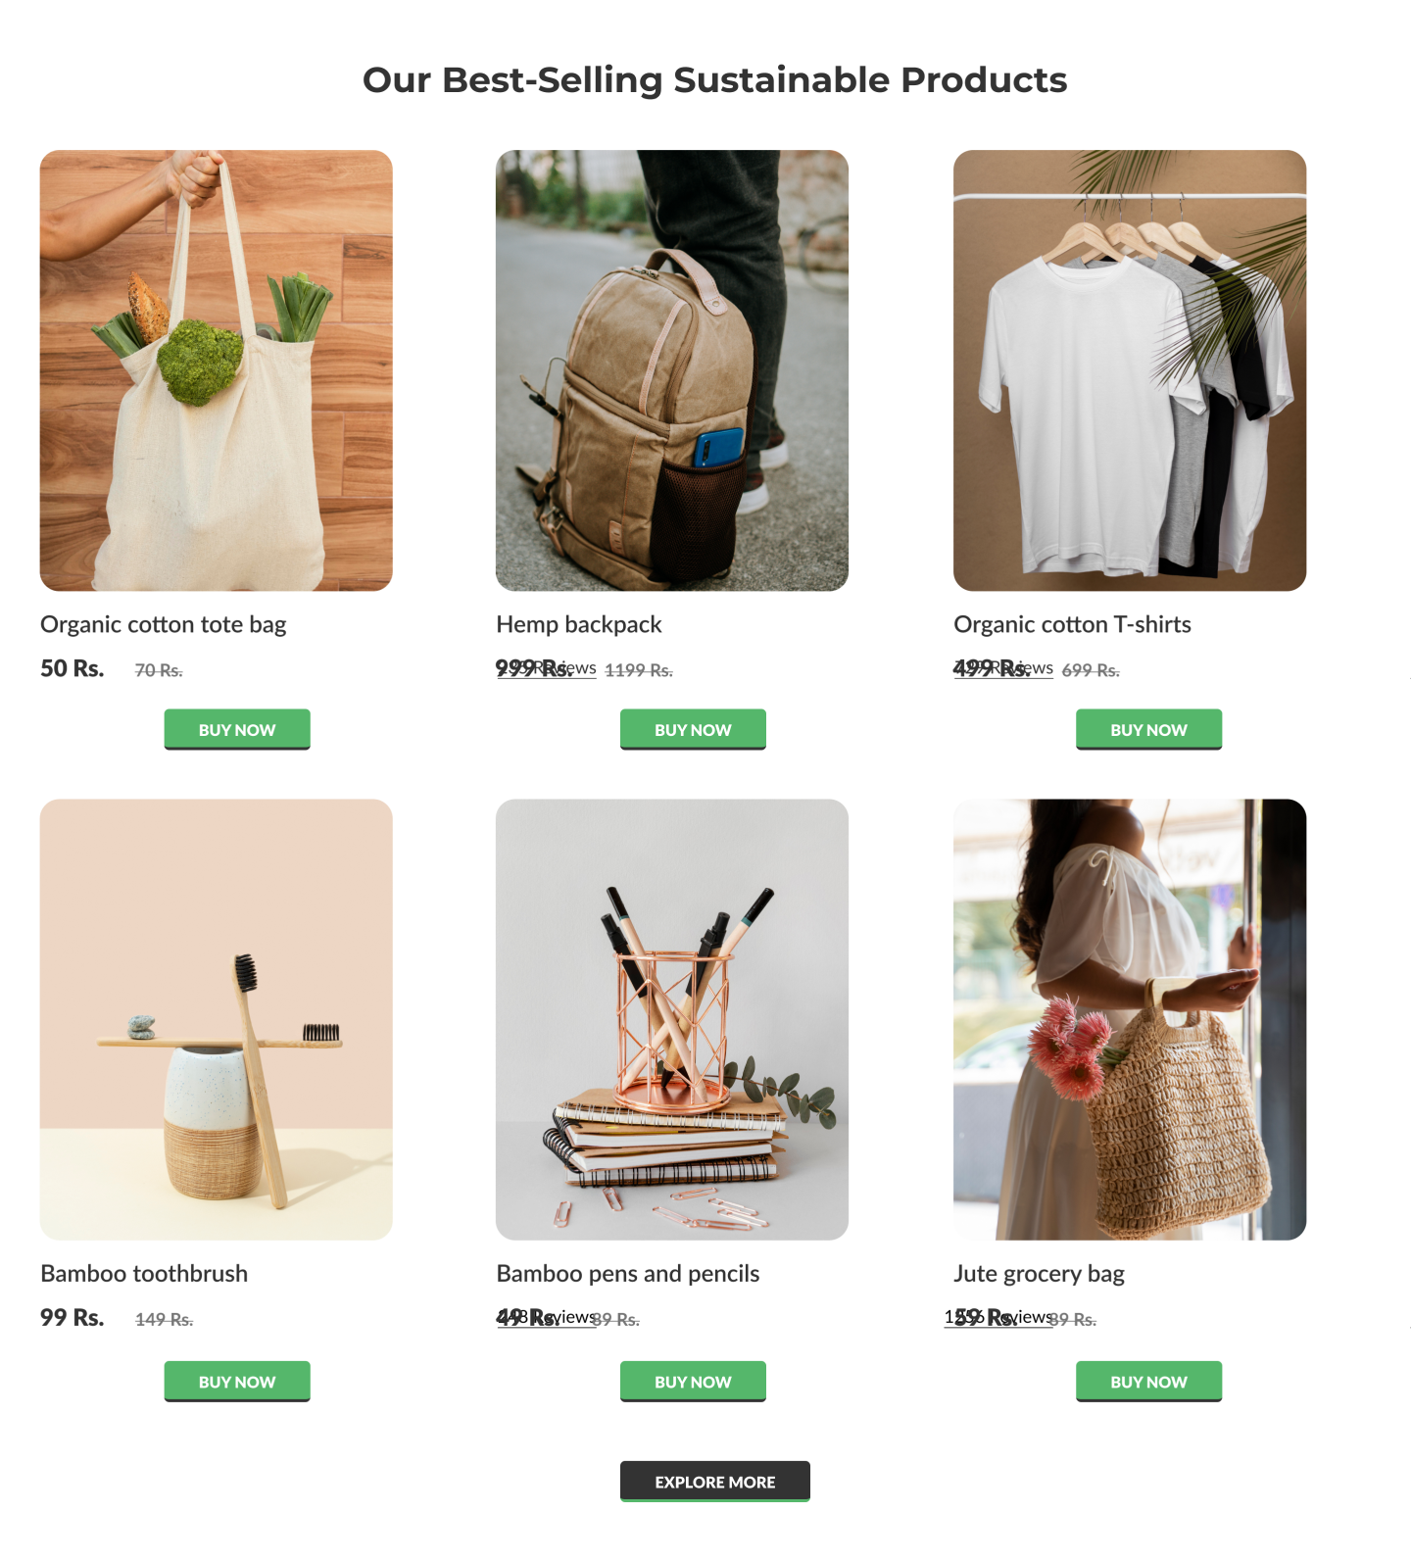

**6.Customer Reveiw:**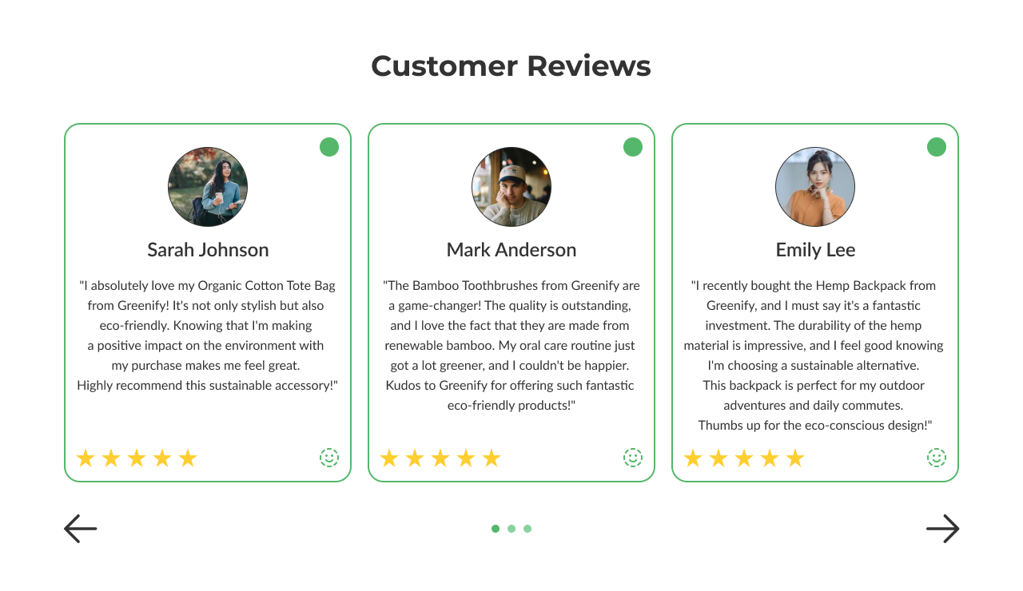

**7.Eco-Friendly Bags:**

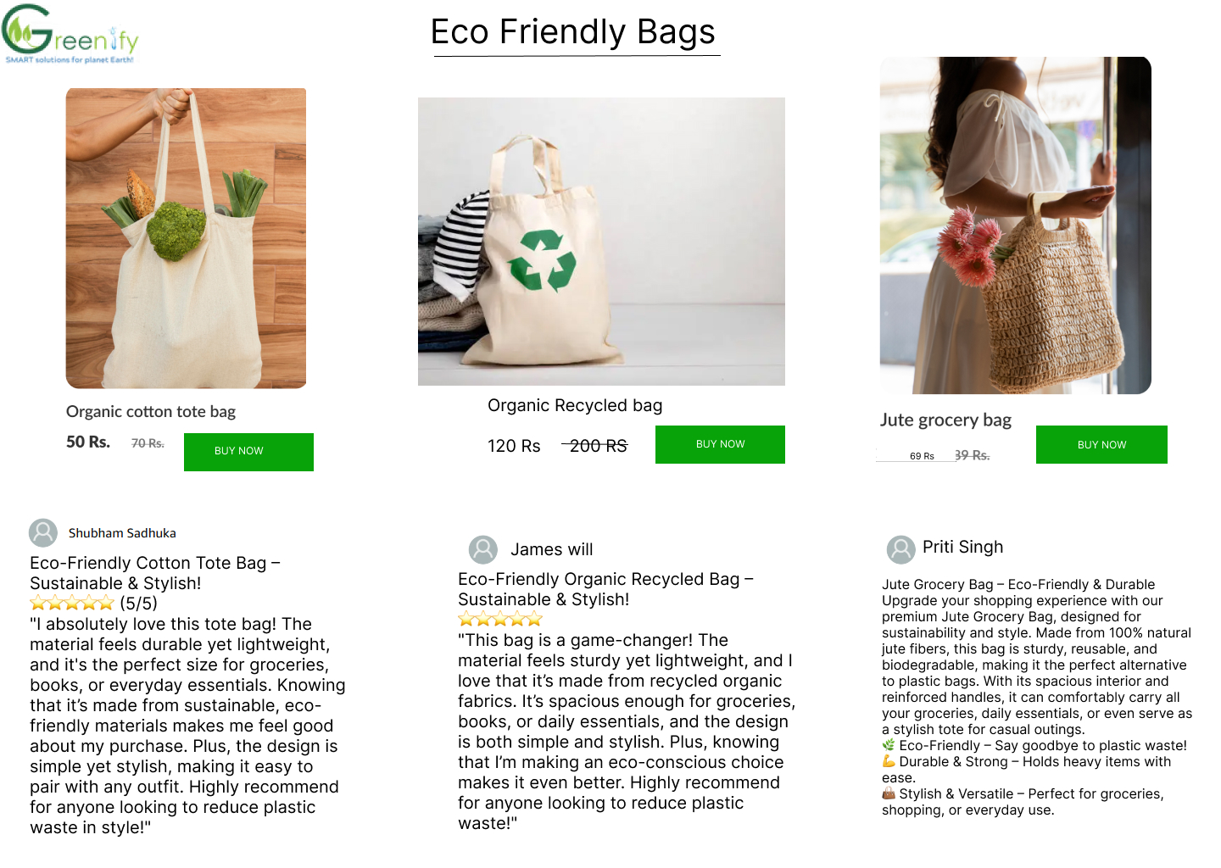

**8.Bamboo Product:**

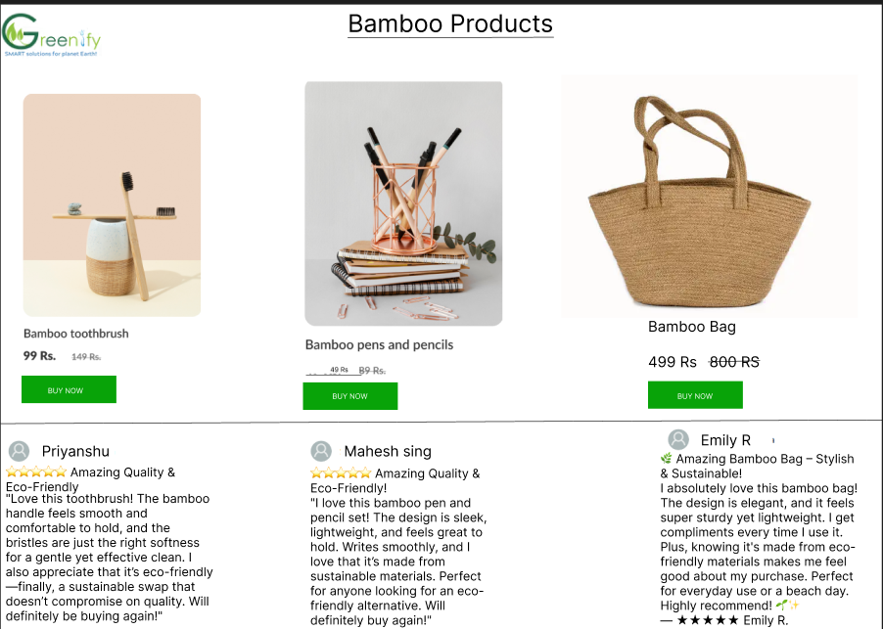

**9.Order Summary:**

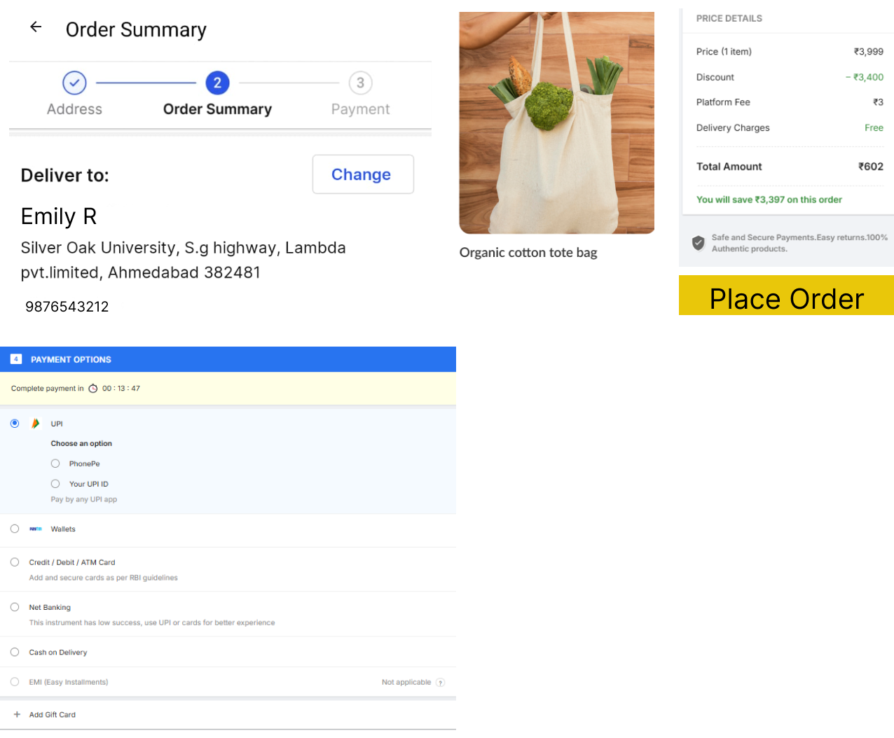

**10.About us:**

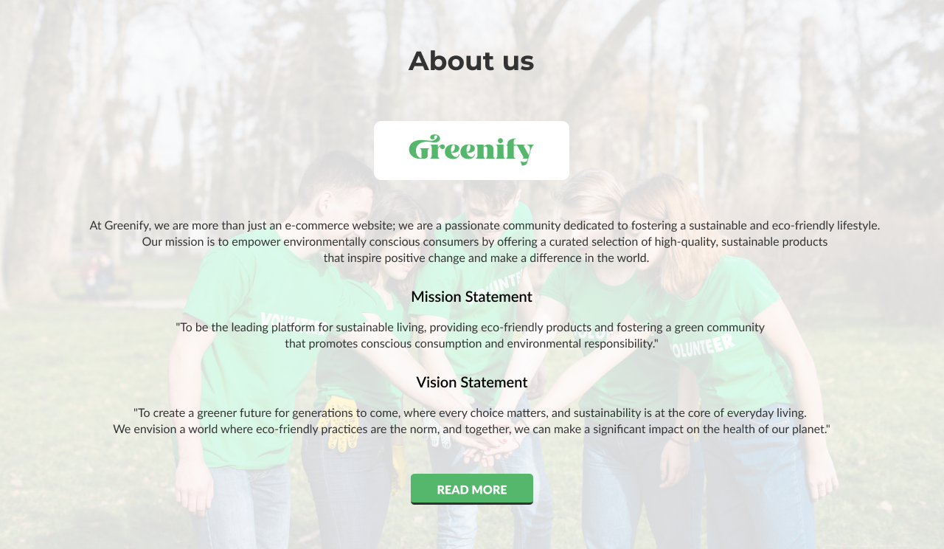

**11.Blogs:**

